**Fitting Curve Sperimentali con EA + lsqcurvefit**

Nel seguente documento sono state prese in considerazione 11 curve sperimentali tra le 450 a disposizione.

Per ognuna di esse è stato effettuato il fitting con l’unione del genetico ed il deterministico, andando ad utilizzare 4 modelli differenti. I modelli utilizzati sono qui sotto riportati:

**Fouquet**

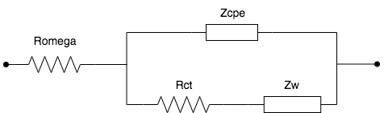

**Fouquet + RC**

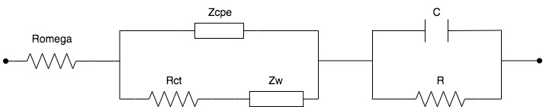

**Dhirde**

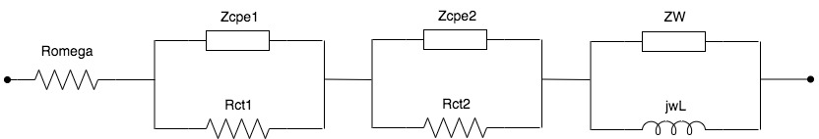

**DhirdeCL**

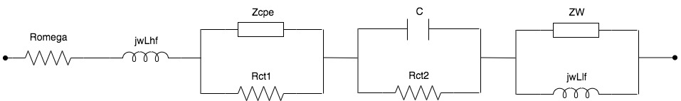

In base ai risultati ottenuti, sotto riportati, si possono effettuare le seguenti considerazioni:

1. Il modello di Dhirde e DhirdeCL riescono ad individuare il terzo cerchio quando presente (Ultima curva).
2. Il modello di DhirdeCL funziona meglio rispetto il modello di Dhirde quando la curva scende sotto lo zero ad alta frequenza. Questo è dovuto alla presenza dell’induttore in serie alla Romega.
3. Il modello di Fouquet + Rc sembra dare risultati migliori rispetto a Fouquet. Si può vedere che in alcune curve, Fouquet+RC cerca di fittare anche la terza curva, ma il risultato è sempre peggiore rispetto a quanto ottenuto con il modello di Dhirde

**Risultati ottenuti**

Nelle prossime pagine sono riportati i risultati ottenuti.

In particolare per ogni curva sono riportati:

* Nome della curva sperimentale;
* Un grafico con la curva sperimentale, il fitting tramite il modello di Fouquet ed il fitting tramite il modello di Fouquet + RC;
* Un grafico con la curva sperimentale, il fitting tramite il modello di Dhirde ed il fitting tramite il modello di DhirceCL;
* Parametri del circuito equivalente ed il valore della funzione obiettivo;
* Grafico che mette in relazione la parte reale e la parte immaginaria con la frequenza;

**170206_1250_dt46_nc_eis-15a_c00**

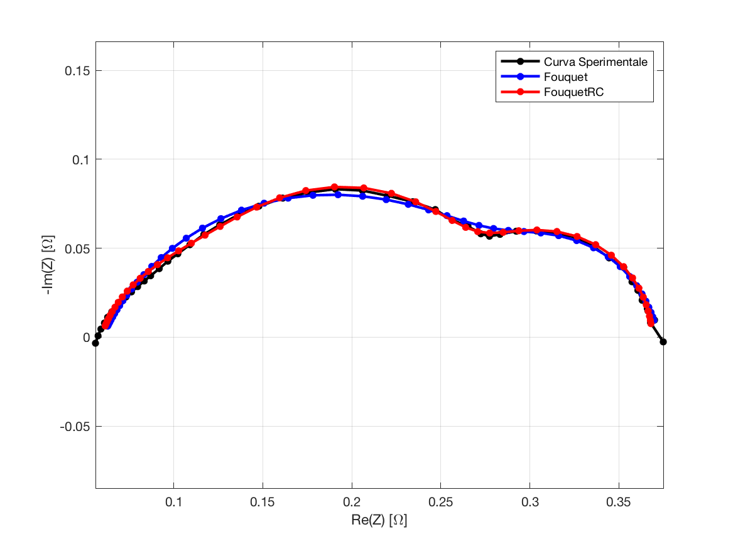

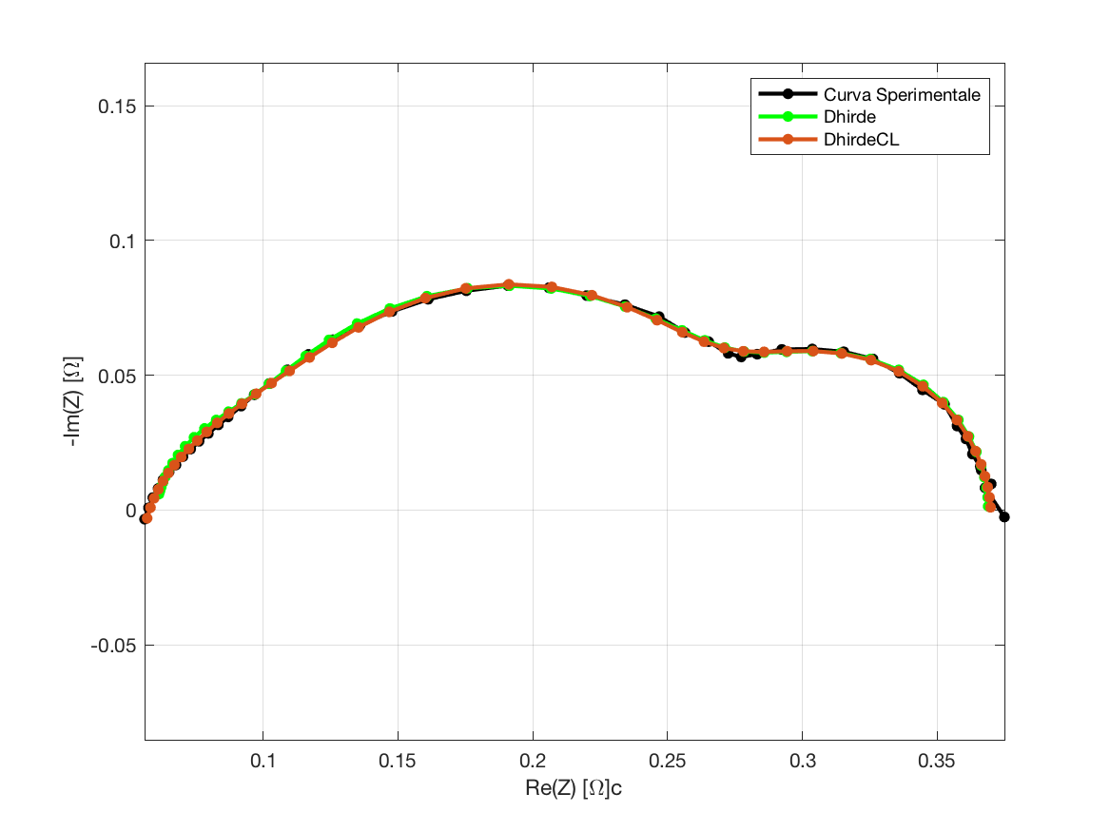

**Fouquet**

Fobj = 0.03444;

|  |  |  |  |  |  |
| --- | --- | --- | --- | --- | --- |
| Romega | Rct | Q | Phi | Rd | Taud |
| 0.0599 | 0.2362 | 0.1450 | 0.7300 | 0.0765 | 0.5218 |

**Fouquet + RC**

Fobj = 0.02279;

|  |  |  |  |  |  |  |  |
| --- | --- | --- | --- | --- | --- | --- | --- |
| Romega | Rct | Q | Phi | Rd | Taud | R | C |
| 0.0593 | 0.0808 | 0.0754 | 0.8114 | 0.1145 | 0.5080 | 0.1141 | 0.1219 |

**Dhirde**

Fobj = 0.02066;

|  |  |  |  |  |  |  |  |  |  |
| --- | --- | --- | --- | --- | --- | --- | --- | --- | --- |
| Romega | Rct1 | Rct2 | Q1 | Q2 | Phi1 | Phi2 | Rd | Taud | L |
| 0.0597 | 0.0267 | 0.1758 | 0.0295 | 0.1212 | 1.0000 | 0.8618 | 0.1070 | 0.5890 | 5.5726 |

**DhirdeCL**

Fobj = **0.01303**;

|  |  |  |  |  |  |  |  |  |  |
| --- | --- | --- | --- | --- | --- | --- | --- | --- | --- |
| Romega | Rct1 | Rct2 | Q | Phi | Rd | Taud | Lhf | Llf | C |
| 0.0473 | 0.1324 | 0.0791 | 0.4653 | 0.5790 | 0.1145 | 0.0320 | 1.08 e-6 | 5.0170 | 2.9419 |

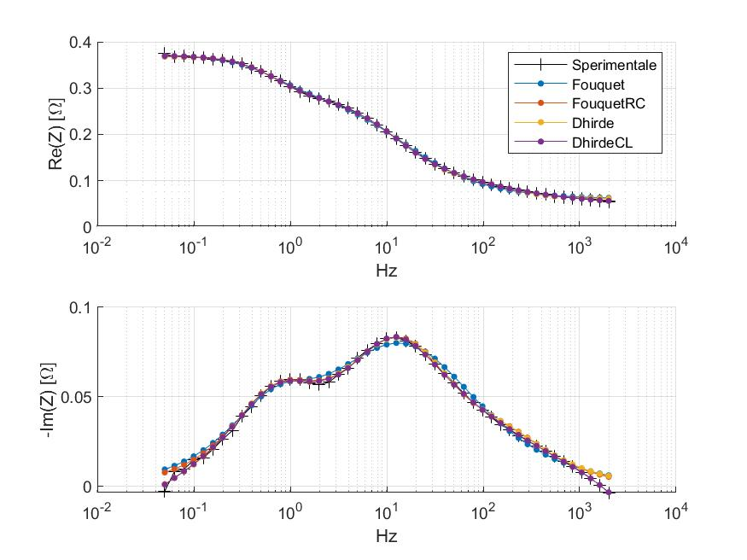

**170206_1250_dt46_nc_eis-15a_c01**

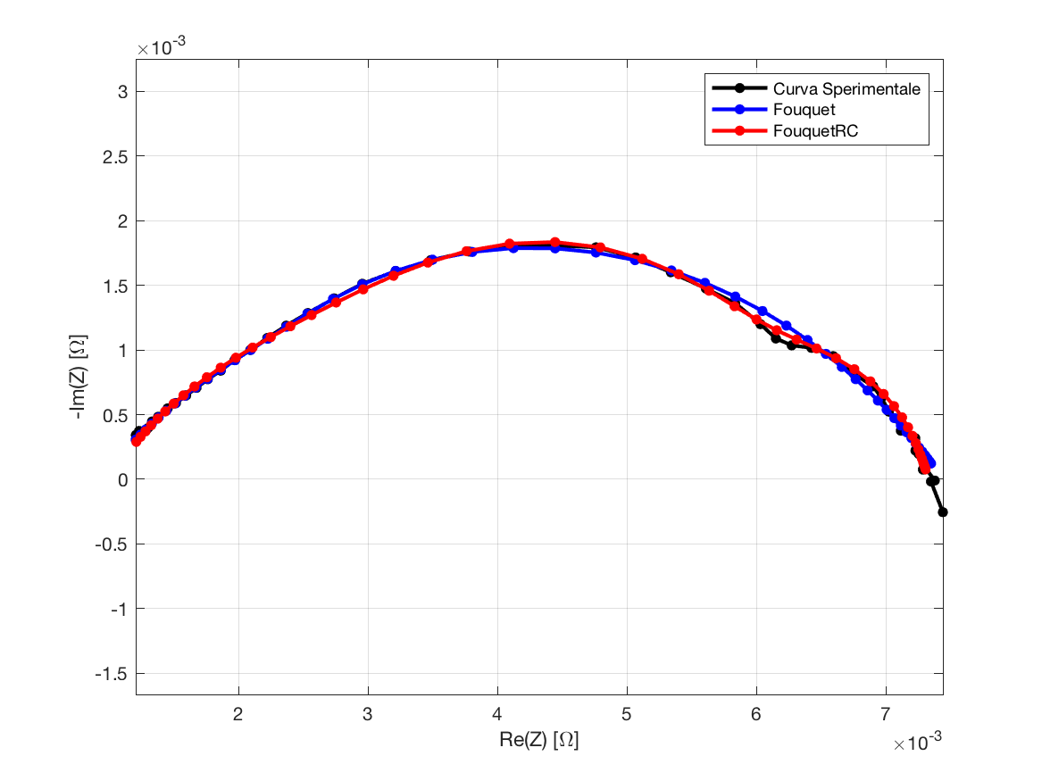

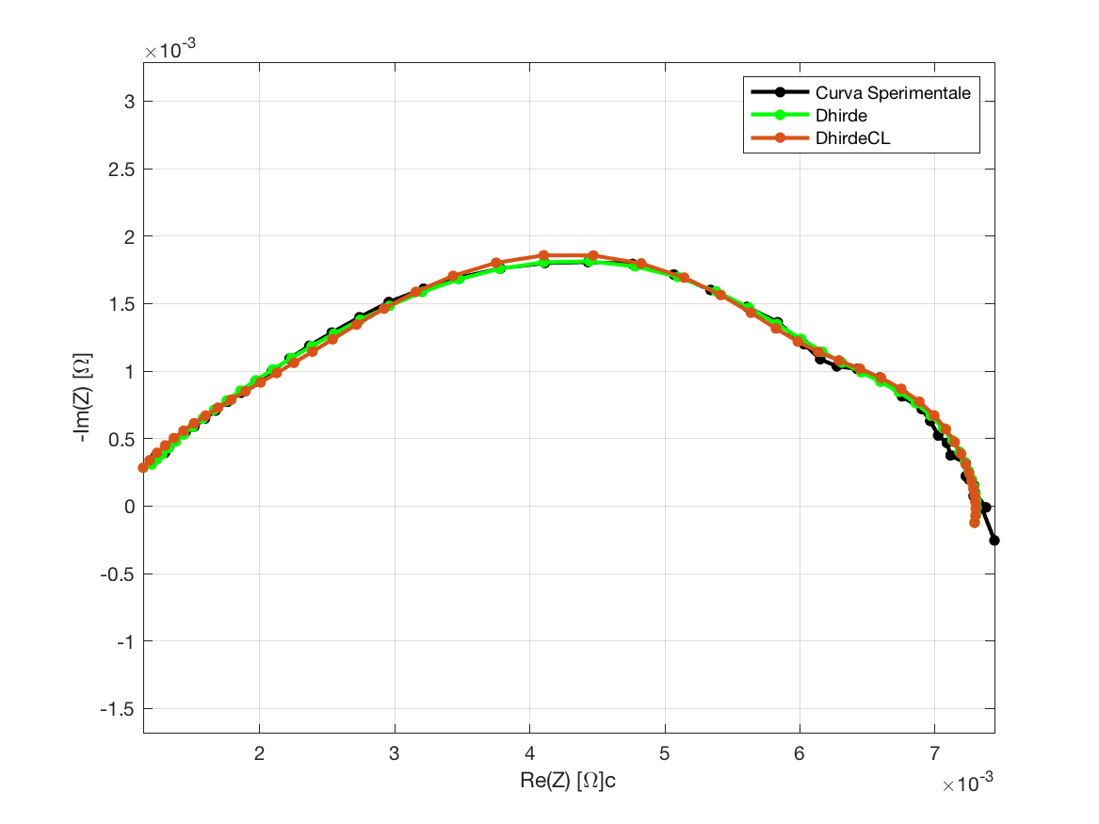

**Fouquet**

Fobj = 0.03185;

|  |  |  |  |  |  |
| --- | --- | --- | --- | --- | --- |
| Romega | Rct | Q | Phi | Rd | Taud |
| 0.0009 | 0.0037 | 7.2787 | 0.6120 | 0.0028 | 0.0078 |

**Fouquet + RC**

Fobj = 0.02429;

|  |  |  |  |  |  |  |  |
| --- | --- | --- | --- | --- | --- | --- | --- |
| Romega | Rct | Q | Phi | Rd | Taud | R | C |
| 0.0010 | 0.0031 | 6.0954 | 0.6464 | 0.0012 | 0.2184 | 0.0021 | 5.0646 |

**Dhirde**

Fobj = **0.01786**;

|  |  |  |  |  |  |  |  |  |  |
| --- | --- | --- | --- | --- | --- | --- | --- | --- | --- |
| Romega | Rct1 | Rct2 | Q1 | Q2 | Phi1 | Phi2 | Rd | Taud | L |
| 0.0009 | 0.0021 | 0.0034 | 6.4353 | 9.9851 | 0.9521 | 0.5834 | 0.0009 | 0.2986 | 0.0129 |

**DhirdeCL**

Fobj = 0.02172;

|  |  |  |  |  |  |  |  |  |  |
| --- | --- | --- | --- | --- | --- | --- | --- | --- | --- |
| Romega | Rct1 | Rct2 | Q | Phi | Rd | Taud | Lhf | Llf | C |
| 0.0007 | 0.0030 | 0.0023 | 10.0000 | 0.5431 | 0.0013 | 0.2515 | 7.72 e-9 | 0.0247 | 4.0779 |

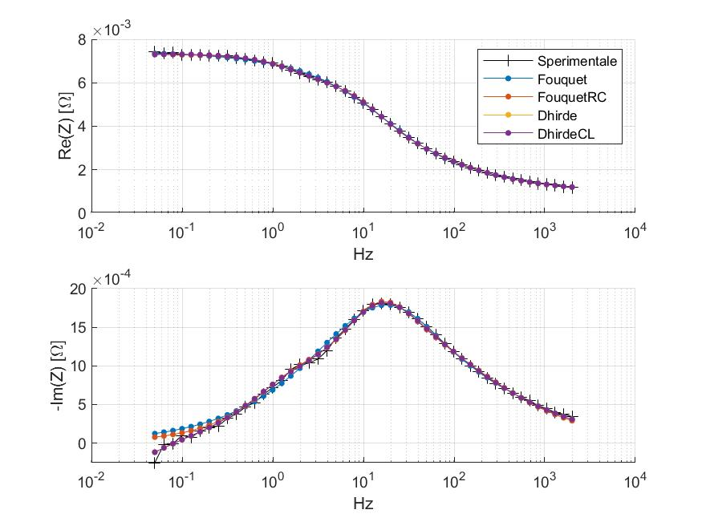

**170206_1250_dt46_nc_eis-15a_c02**

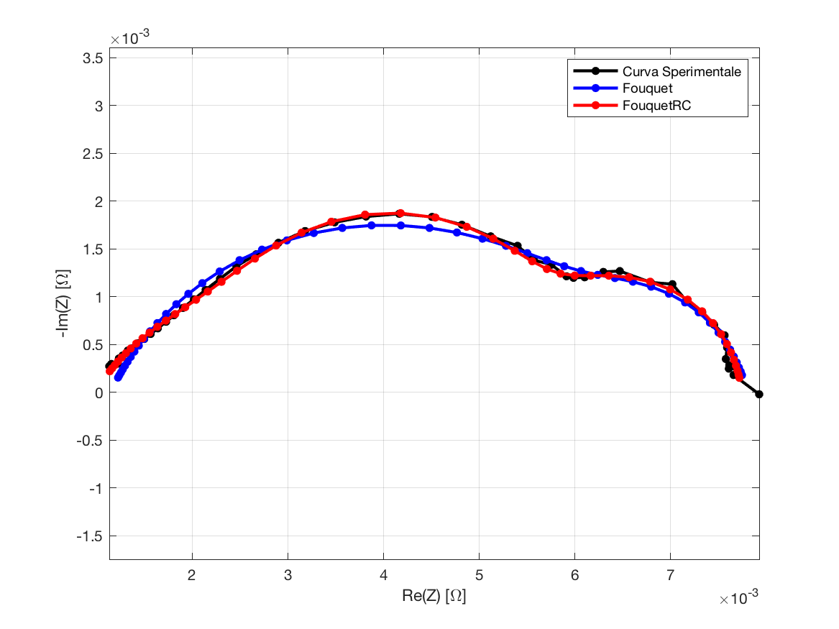

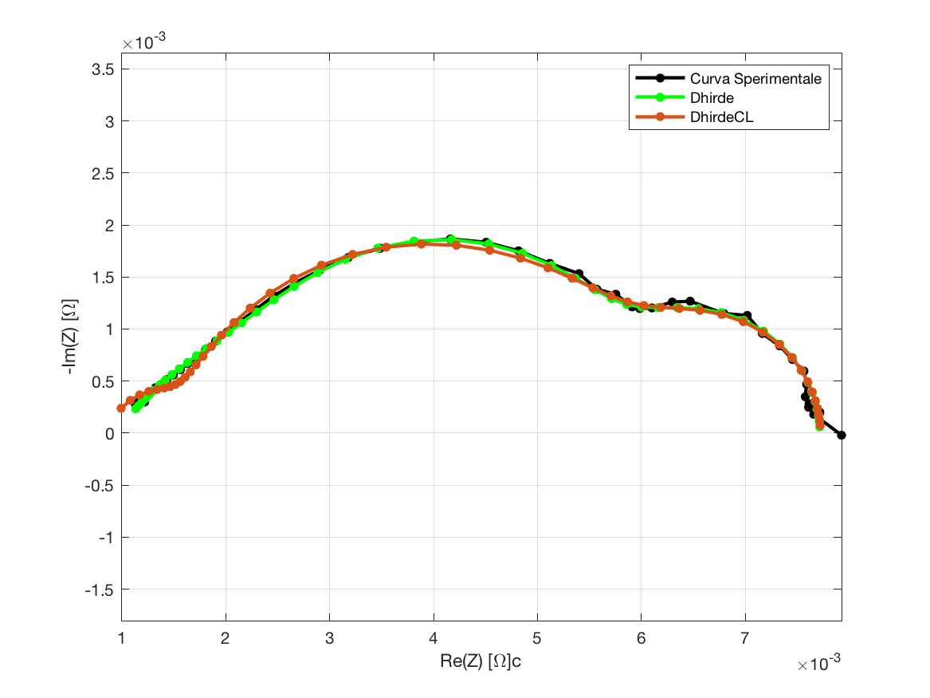

**Fouquet**

Fobj = 0.04212;

|  |  |  |  |  |  |
| --- | --- | --- | --- | --- | --- |
| Romega | Rct | Q | Phi | Rd | Taud |
| 0.0011 | 0.0054 | 6.7931 | 0.7125 | 0.0013 | 0.4780 |

**Fouquet + RC**

Fobj = 0.02036;

|  |  |  |  |  |  |  |  |
| --- | --- | --- | --- | --- | --- | --- | --- |
| Romega | Rct | Q | Phi | Rd | Taud | R | C |
| 0.0010 | 0.0020 | 6.5978 | 0.6710 | 0.0022 | 0.4289 | 0.0026 | 4.6975 |

**Dhirde**

Fobj = **0.01650**;

|  |  |  |  |  |  |  |  |  |  |
| --- | --- | --- | --- | --- | --- | --- | --- | --- | --- |
| Romega | Rct1 | Rct2 | Q1 | Q2 | Phi1 | Phi2 | Rd | Taud | L |
| 0.0010 | 0.0020 | 0.0026 | 10.0000 | 5.1149 | 0.6253 | 0.9759 | 0.0022 | 0.4956 | 0.1874 |

**DhirdeCL**

Fobj = 0.02603;

|  |  |  |  |  |  |  |  |  |  |
| --- | --- | --- | --- | --- | --- | --- | --- | --- | --- |
| Romega | Rct1 | Rct2 | Q | Phi | Rd | Taud | Lhf | Llf | C |
| 0.0007 | 0.0043 | 0.0008 | 5.1401 | 0.8161 | 0.0020 | 0.5241 | 1.85 e-8 | 0.1763 | 0.1355 |

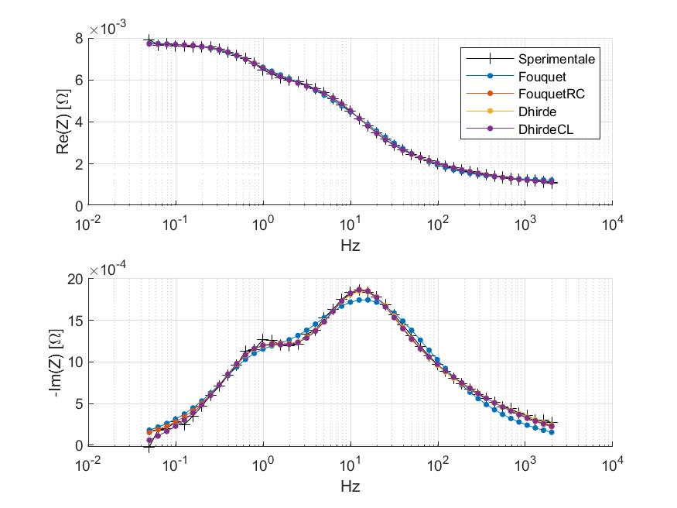

**170206_1250_dt46_nc_eis-15a_c03**

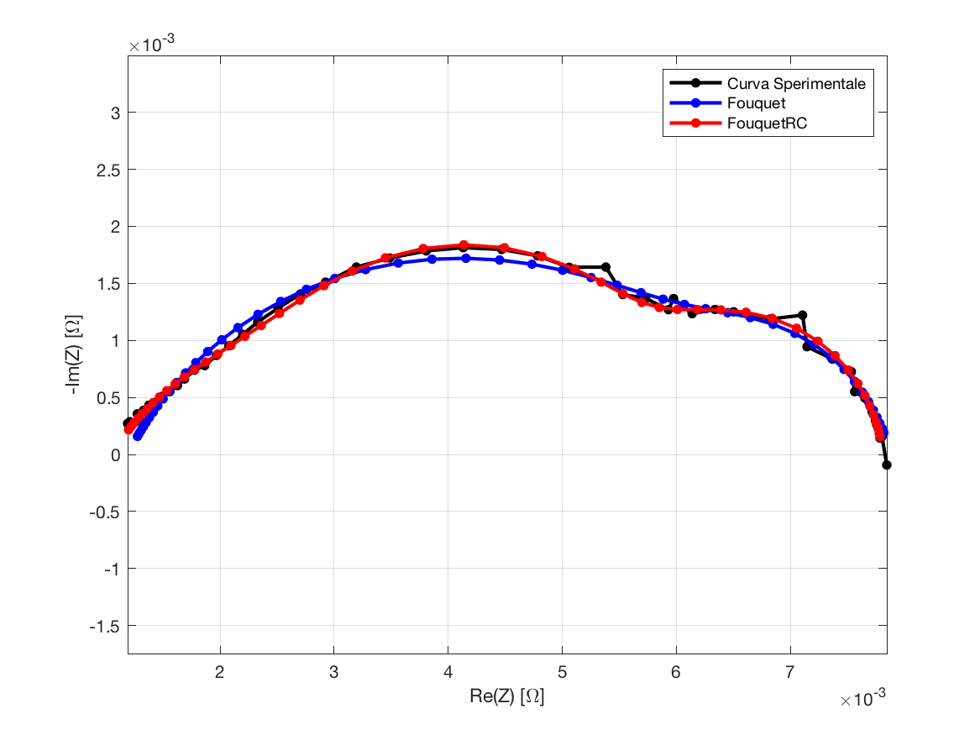

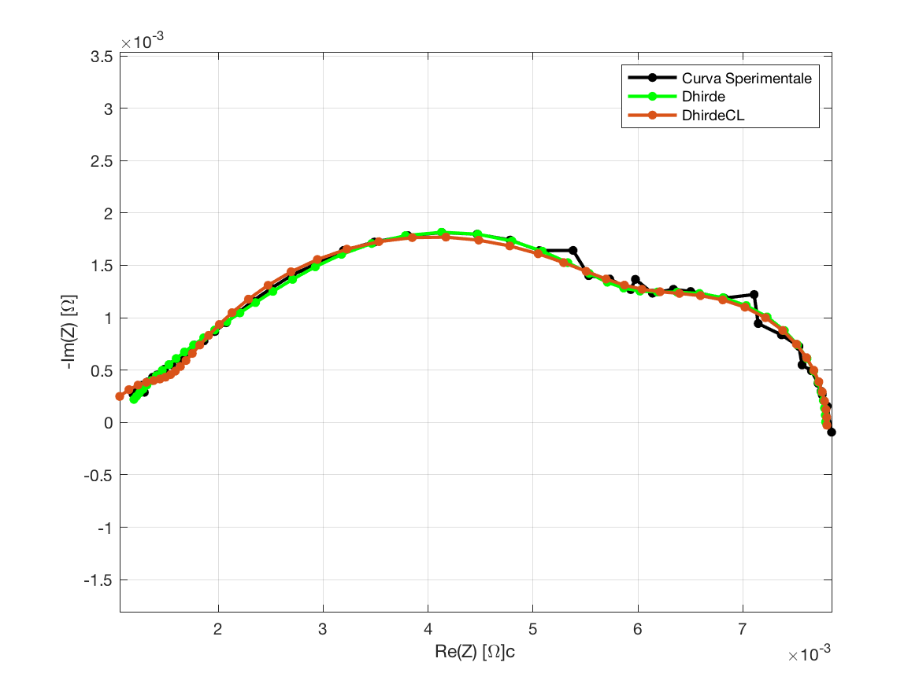

**Fouquet**

Fobj = 0.04143;

|  |  |  |  |  |  |
| --- | --- | --- | --- | --- | --- |
| Romega | Rct | Q | Phi | Rd | Taud |
| 0.0012 | 0.0054 | 7.5936 | 0.6961 | 0.0013 | 0.4472 |

**Fouquet + RC**

Fobj = 0.02401;

|  |  |  |  |  |  |  |  |
| --- | --- | --- | --- | --- | --- | --- | --- |
| Romega | Rct | Q | Phi | Rd | Taud | R | C |
| 0.0011 | 0.0021 | 6.7467 | 0.6712 | 0.0022 | 0.4149 | 0.0024 | 5.3801 |

**Dhirde**

Fobj = **0.02316**;

|  |  |  |  |  |  |  |  |  |  |
| --- | --- | --- | --- | --- | --- | --- | --- | --- | --- |
| Romega | Rct1 | Rct2 | Q1 | Q2 | Phi1 | Phi2 | Rd | Taud | L |
| 0.0010 | 0.0021 | 0.0025 | 10.0000 | 6.3142 | 0.6346 | 0.9650 | 0.0022 | 0.5003 | 0.1105 |

**DhirdeCL**

Fobj = 0.02855;

|  |  |  |  |  |  |  |  |  |  |
| --- | --- | --- | --- | --- | --- | --- | --- | --- | --- |
| Romega | Rct1 | Rct2 | Q | Phi | Rd | Taud | Lhf | Llf | C |
| 0.0007 | 0.0045 | 0.0007 | 6.2746 | 0.7765 | 0.0019 | 0.5451 | 1.81 e-8 | 0.0618 | 0.1232 |

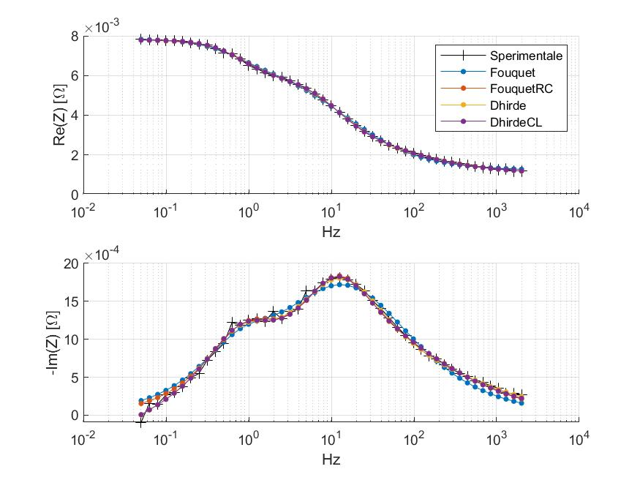

**170206_1250_dt46_nc_eis-15a_c04**

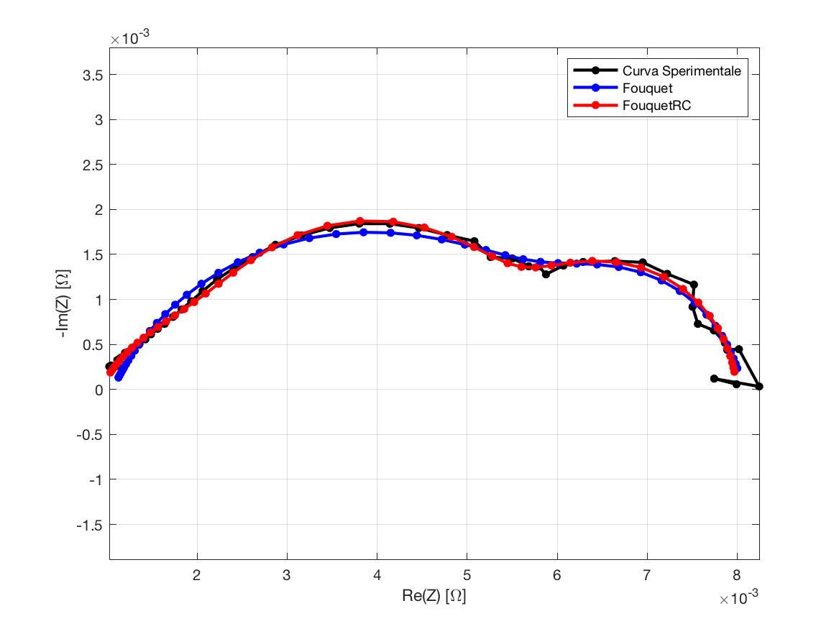

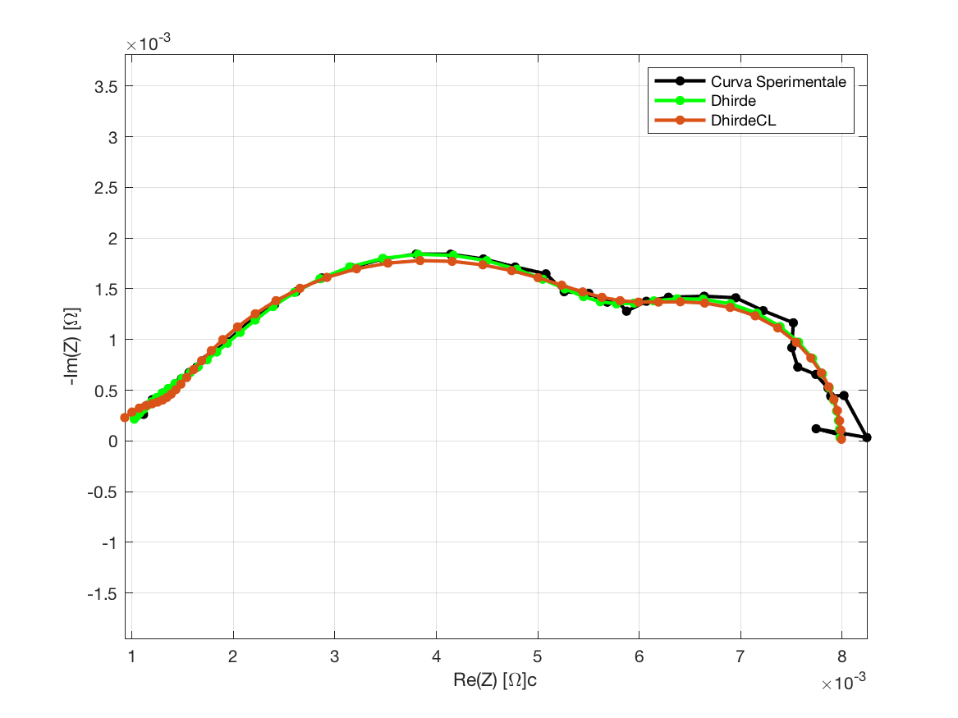

**Fouquet**

Fobj = 0.05131;

|  |  |  |  |  |  |
| --- | --- | --- | --- | --- | --- |
| Romega | Rct | Q | Phi | Rd | Taud |
| 0.0011 | 0.0052 | 7.1762 | 0.7244 | 0.0019 | 0.5239 |

**Fouquet + RC**

Fobj = 0.03303;

|  |  |  |  |  |  |  |  |
| --- | --- | --- | --- | --- | --- | --- | --- |
| Romega | Rct | Q | Phi | Rd | Taud | R | C |
| 0.0009 | 0.0017 | 5.2613 | 0.7181 | 0.0028 | 0.5029 | 0.0026 | 5.0937 |

**Dhirde**

Fobj = **0.02469**;

|  |  |  |  |  |  |  |  |  |  |
| --- | --- | --- | --- | --- | --- | --- | --- | --- | --- |
| Romega | Rct1 | Rct2 | Q1 | Q2 | Phi1 | Phi2 | Rd | Taud | L |
| 0.0009 | 0.0033 | 0.0011 | 5.6572 | 6.5154 | 0.9078 | 0.6926 | 0.0027 | 0.5886 | 0.1469 |

**DhirdeCL**

Fobj = 0.03090;

|  |  |  |  |  |  |  |  |  |  |
| --- | --- | --- | --- | --- | --- | --- | --- | --- | --- |
| Romega | Rct1 | Rct2 | Q | Phi | Rd | Taud | Lhf | Llf | C |
| 0.0006 | 0.0045 | 0.0006 | 7.1543 | 0.7661 | 0.0023 | 0.6390 | 1.32 e-8 | 0.0864 | 0.1625 |

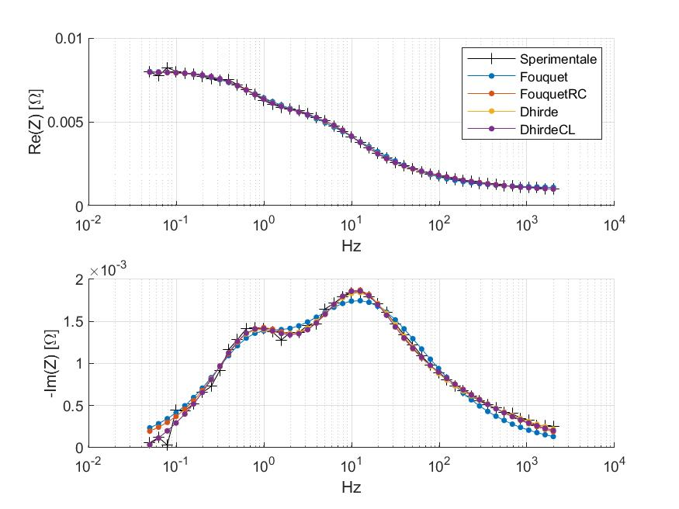

**170206_1250_dt46_nc_eis-15a_c05**

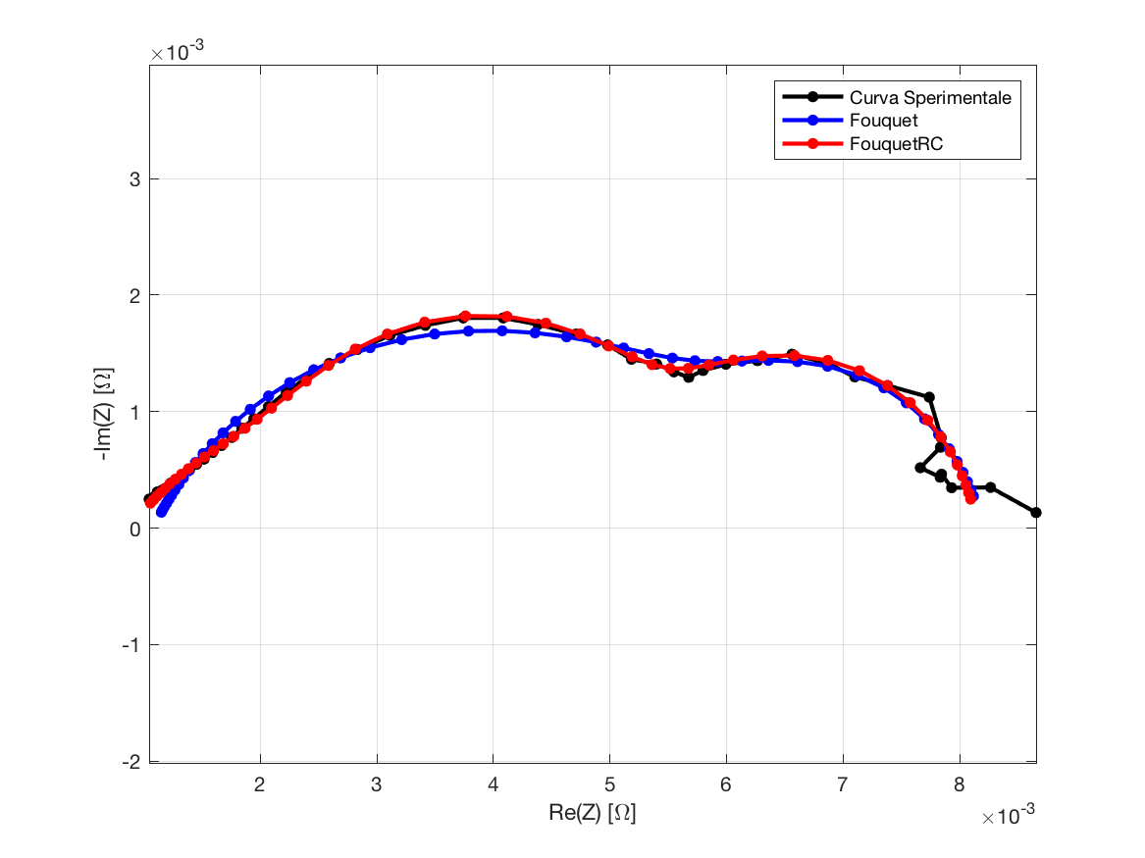

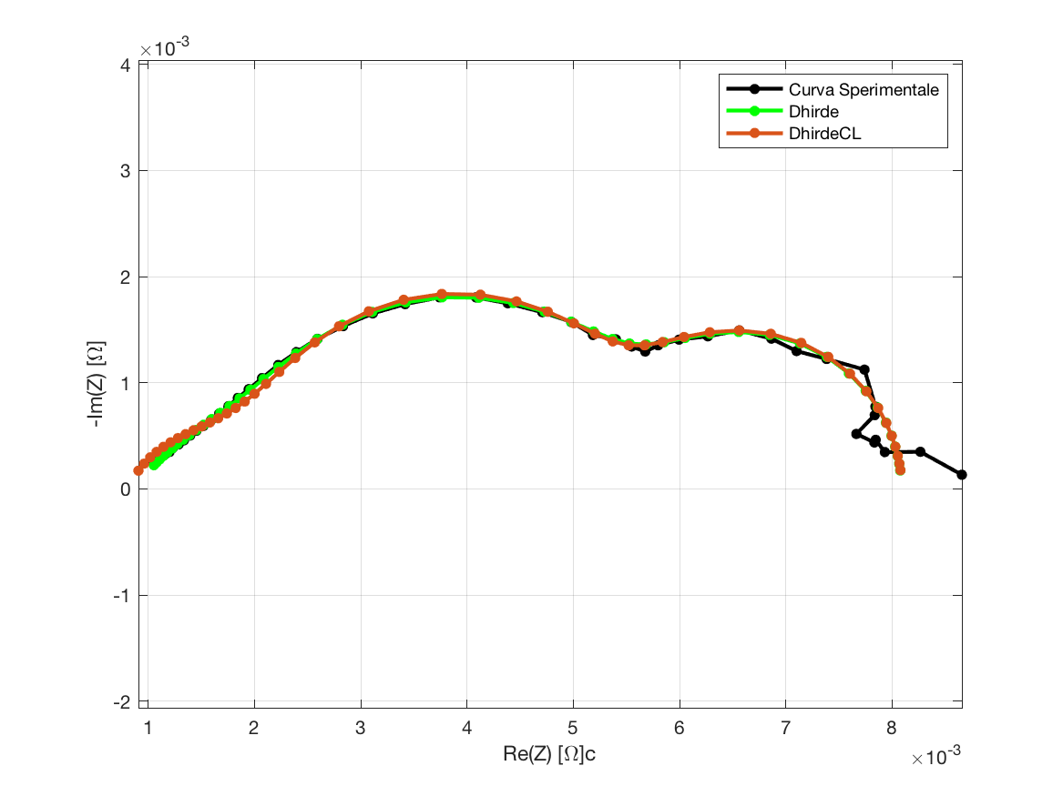

**Fouquet**

Fobj = 0.04892;

|  |  |  |  |  |  |
| --- | --- | --- | --- | --- | --- |
| Romega | Rct | Q | Phi | Rd | Taud |
| 0.0011 | 0.0051 | 8.0417 | 0.7075 | 0.0020 | 0.5715 |

**Fouquet + RC**

Fobj = 0.02836;

|  |  |  |  |  |  |  |  |
| --- | --- | --- | --- | --- | --- | --- | --- |
| Romega | Rct | Q | Phi | Rd | Taud | R | C |
| 0.0009 | 0.0019 | 9.0576 | 0.6325 | 0.0029 | 0.5188 | 0.0024 | 5.5124 |

**Dhirde**

Fobj = **0.02631**;

|  |  |  |  |  |  |  |  |  |  |
| --- | --- | --- | --- | --- | --- | --- | --- | --- | --- |
| Romega | Rct1 | Rct2 | Q1 | Q2 | Phi1 | Phi2 | Rd | Taud | L |
| 0.0009 | 0.0014 | 0.0029 | 9.9997 | 5.8385 | 0.6299 | 0.9428 | 0.0030 | 0.6153 | 0.6866 |

**DhirdeCL**

Fobj = 0.03055;

|  |  |  |  |  |  |  |  |  |  |
| --- | --- | --- | --- | --- | --- | --- | --- | --- | --- |
| Romega | Rct1 | Rct2 | Q | Phi | Rd | Taud | Lhf | Llf | C |
| 0.0004 | 0.0021 | 0.0026 | 10.0000 | 0.5117 | 0.0031 | 0.5947 | 1.68 e-8 | 0.7271 | 4.9887 |

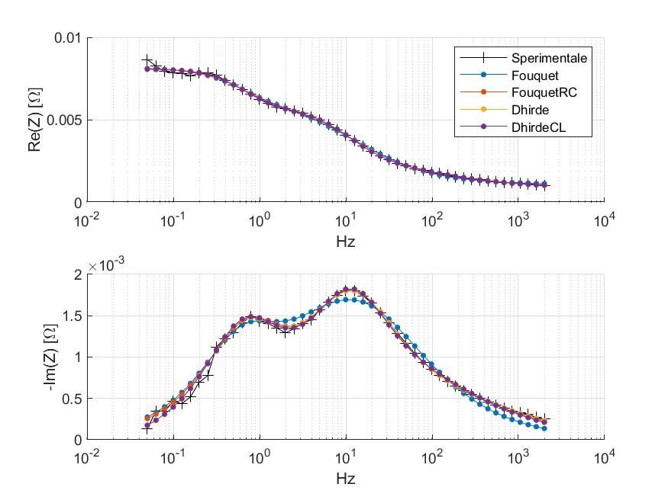

**170206_1330_dt46_nc_eis-25a_c00**

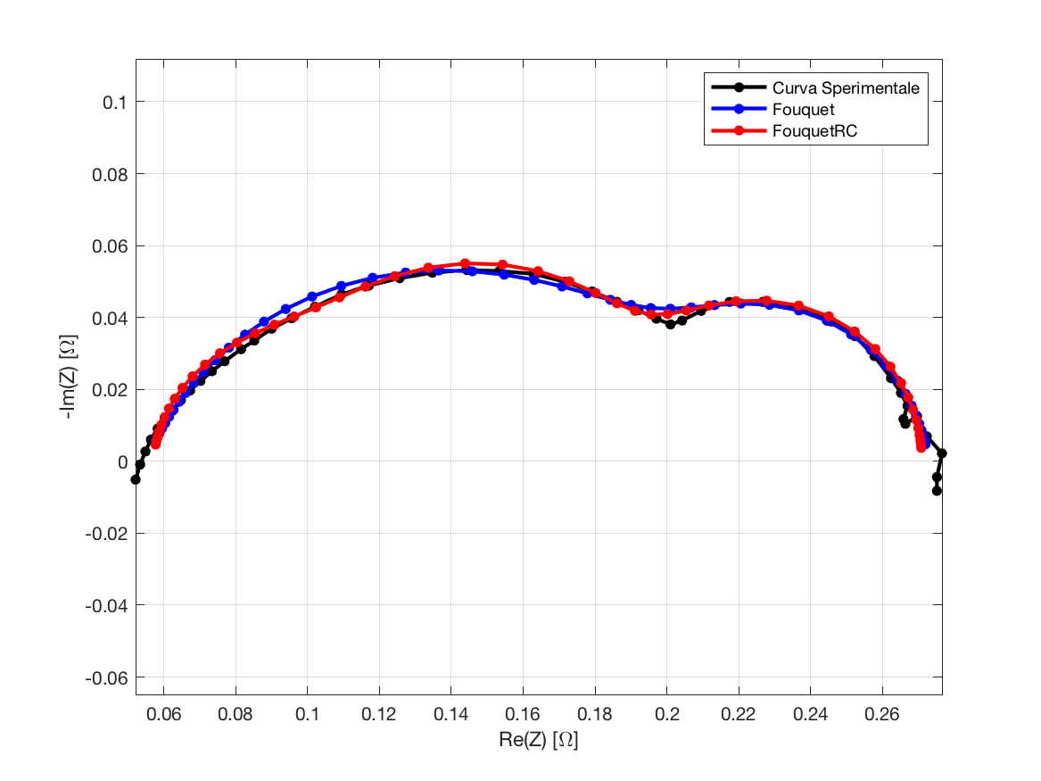

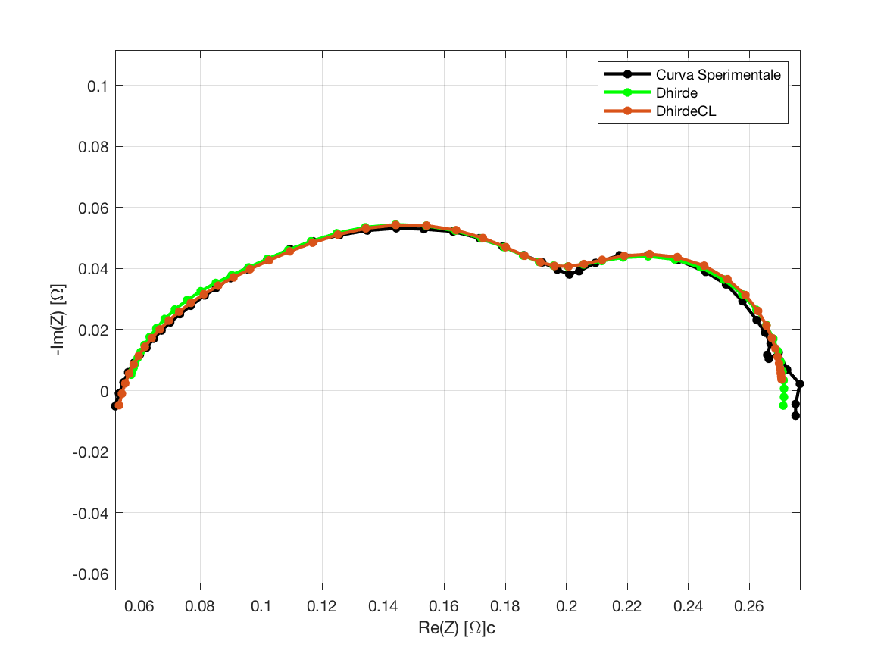

**Fouquet**

Fobj = 0.04494;

|  |  |  |  |  |  |
| --- | --- | --- | --- | --- | --- |
| Romega | Rct | Q | Phi | Rd | Taud |
| 0.0551 | 0.1486 | 0.1285 | 0.7516 | 0.0694 | 0.3317 |

**Fouquet + RC**

Fobj = 0.03616;

|  |  |  |  |  |  |  |  |
| --- | --- | --- | --- | --- | --- | --- | --- |
| Romega | Rct | Q | Phi | Rd | Taud | R | C |
| 0.0571 | 0.0498 | 0.0321 | 0.9471 | 0.0911 | 0.3474 | 0.0730 | 0.1203 |

**Dhirde**

Fobj = 0.03816;

|  |  |  |  |  |  |  |  |  |  |
| --- | --- | --- | --- | --- | --- | --- | --- | --- | --- |
| Romega | Rct1 | Rct2 | Q1 | Q2 | Phi1 | Phi2 | Rd | Taud | L |
| 0.0557 | 0.0392 | 0.0873 | 0.0485 | 0.1331 | 0.9254 | 0.9328 | 0.0893 | 0.3817 | 2.8737 |

**DhirdeCL**

Fobj = **0.02763**;

|  |  |  |  |  |  |  |  |  |  |
| --- | --- | --- | --- | --- | --- | --- | --- | --- | --- |
| Romega | Rct1 | Rct2 | Q | Phi | Rd | Taud | Lhf | Llf | C |
| 0.0470 | 0.0842 | 0.1397 | 0.2015 | 0.6915 | 0.0662 | 0.0237 | 1.07 e-6 | 0.0158 | 1.3187 |

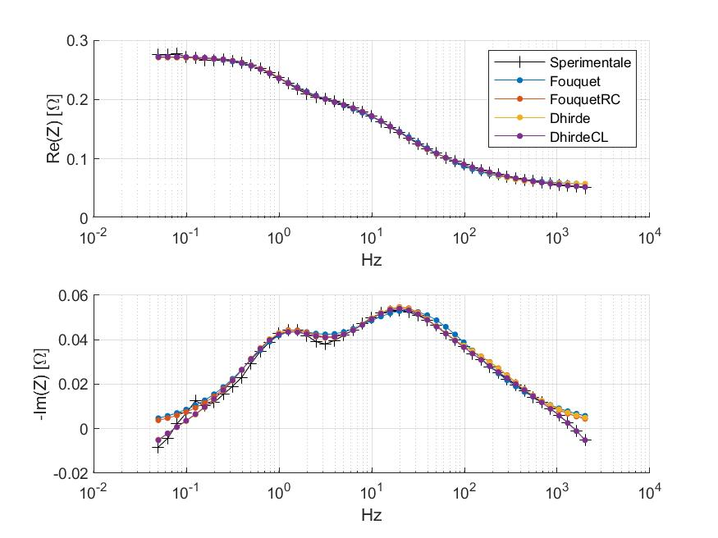

**170206_1410_dt46_nc_eis-40a_c00**

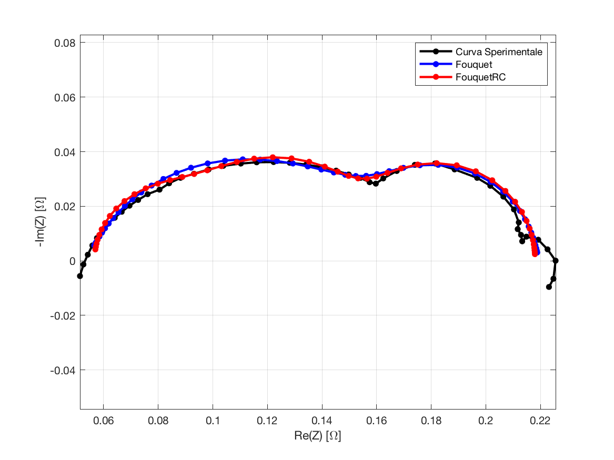

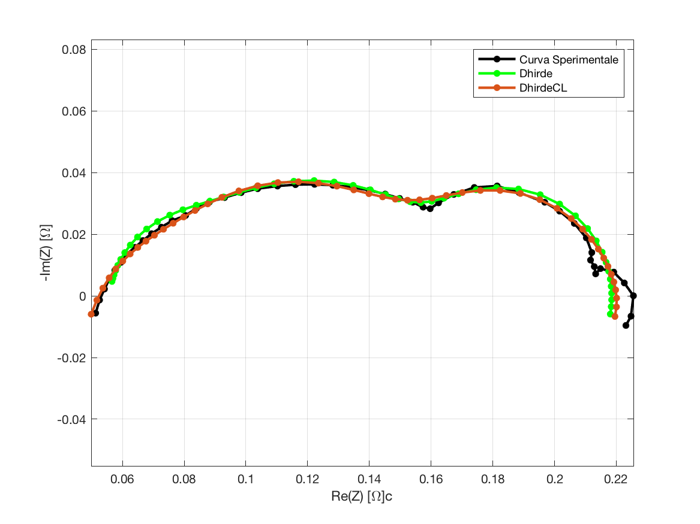

**Fouquet**

Fobj = 0.06463;

|  |  |  |  |  |  |
| --- | --- | --- | --- | --- | --- |
| Romega | Rct | Q | Phi | Rd | Taud |
| 0.0538 | 0.1032 | 0.1295 | 0.7507 | 0.0625 | 0.2616 |

**Fouquet + RC**

Fobj = 0.05809;

|  |  |  |  |  |  |  |  |
| --- | --- | --- | --- | --- | --- | --- | --- |
| Romega | Rct | Q | Phi | Rd | Taud | R | C |
| 0.0566 | 0.0387 | 0.0218 | 1.0000 | 0.0760 | 0.2816 | 0.0467 | 0.1437 |

**Dhirde**

Fobj = 0.05594;

|  |  |  |  |  |  |  |  |  |  |
| --- | --- | --- | --- | --- | --- | --- | --- | --- | --- |
| Romega | Rct1 | Rct2 | Q1 | Q2 | Phi1 | Phi2 | Rd | Taud | L |
| 0.0553 | 0.0274 | 0.0625 | 0.0304 | 0.1656 | 1.0000 | 0.8951 | 0.0734 | 0.3096 | 2.0036 |

**DhirdeCL**

Fobj = **0.04526**;

|  |  |  |  |  |  |  |  |  |  |
| --- | --- | --- | --- | --- | --- | --- | --- | --- | --- |
| Romega | Rct1 | Rct2 | Q | Phi | Rd | Taud | Lhf | Llf | C |
| 0.0237 | 0.1248 | 0.0288 | 0.8551 | 0.3702 | 0.0518 | 0.2850 | 1.56 e-6 | 0.6544 | 0.1495 |

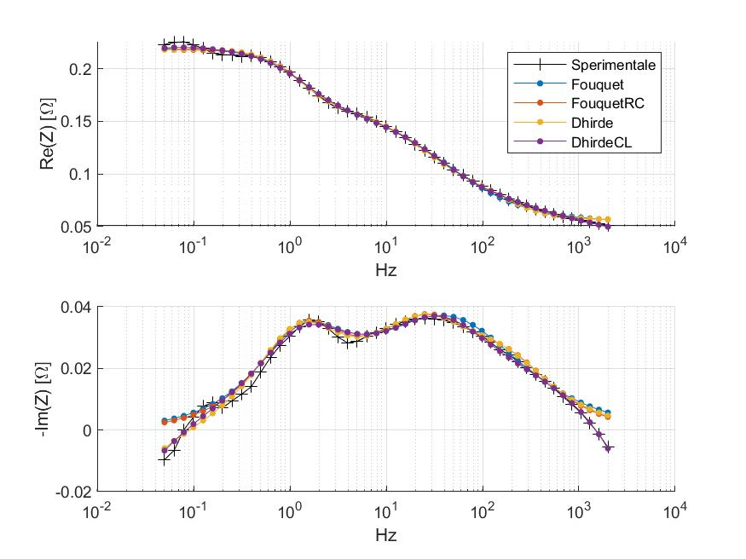

**170206_1410_dt46_nc_eis-40a_c02**

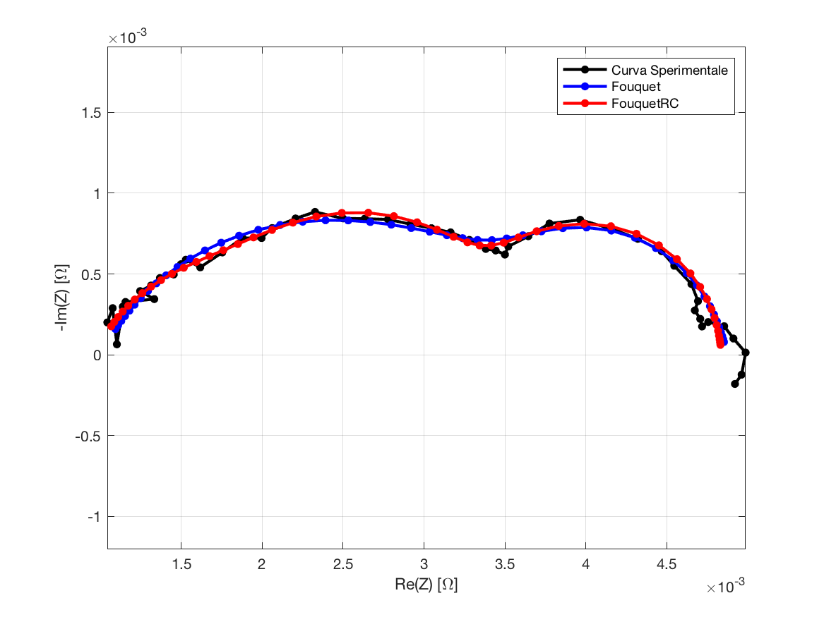

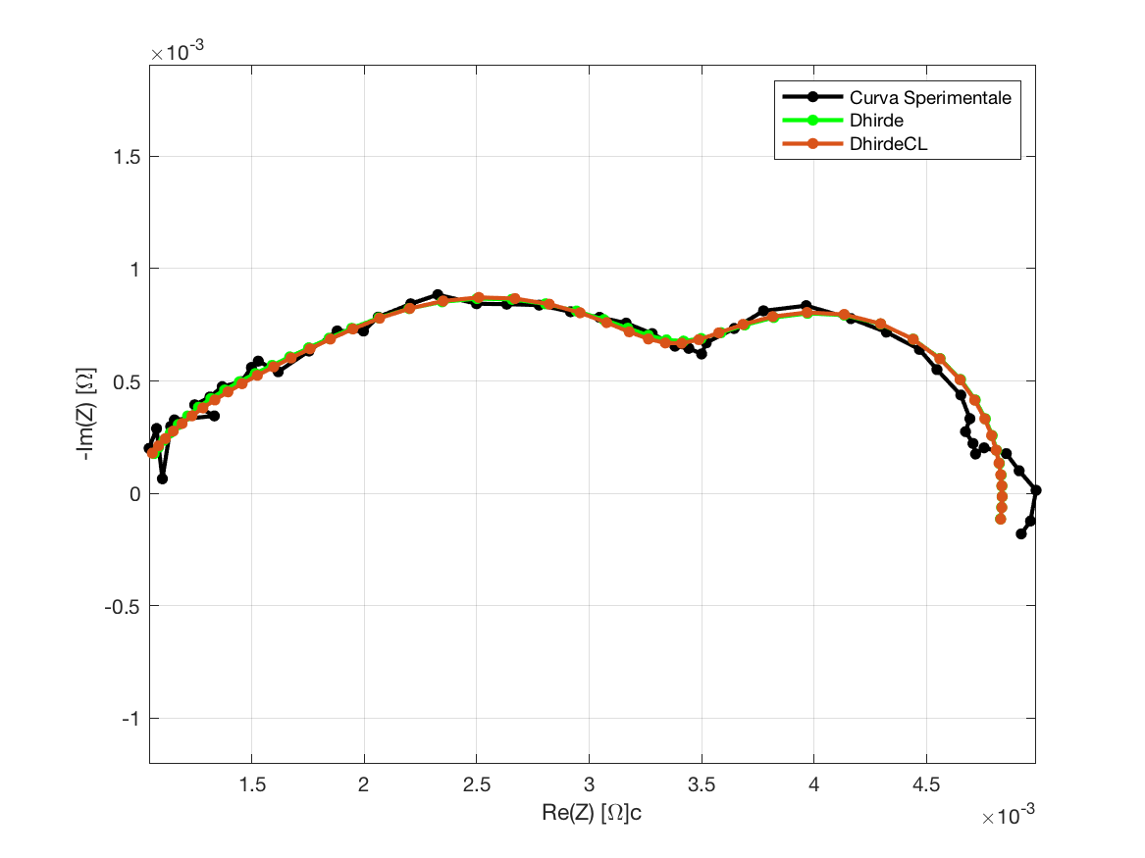

**Fouquet**

Fobj = 0.06487;

|  |  |  |  |  |  |
| --- | --- | --- | --- | --- | --- |
| Romega | Rct | Q | Phi | Rd | Taud |
| 0.0010 | 0.0025 | 7.0888 | 0.6993 | 0.0013 | 0.2684 |

**Fouquet + RC**

Fobj = 0.05630;

|  |  |  |  |  |  |  |  |
| --- | --- | --- | --- | --- | --- | --- | --- |
| Romega | Rct | Q | Phi | Rd | Taud | R | C |
| 0.0010 | 0.0011 | 3.3276 | 0.7760 | 0.0017 | 0.2779 | 0.0010 | 5.7800 |

**Dhirde**

Fobj = **0.05477**;

|  |  |  |  |  |  |  |  |  |  |
| --- | --- | --- | --- | --- | --- | --- | --- | --- | --- |
| Romega | Rct1 | Rct2 | Q1 | Q2 | Phi1 | Phi2 | Rd | Taud | L |
| 0.0010 | 0.0015 | 0.0007 | 6.3215 | 2.9457 | 0.8905 | 0.8187 | 0.0017 | 0.3132 | 0.0518 |

**DhirdeCL**

Fobj = 0.05502;

|  |  |  |  |  |  |  |  |  |  |
| --- | --- | --- | --- | --- | --- | --- | --- | --- | --- |
| Romega | Rct1 | Rct2 | Q | Phi | Rd | Taud | Lhf | Llf | C |
| 0.0009 | 0.0014 | 0.0009 | 10.0000 | 0.6204 | 0.0017 | 0.3065 | 3.14 e-9 | 0.0505 | 6.3330 |

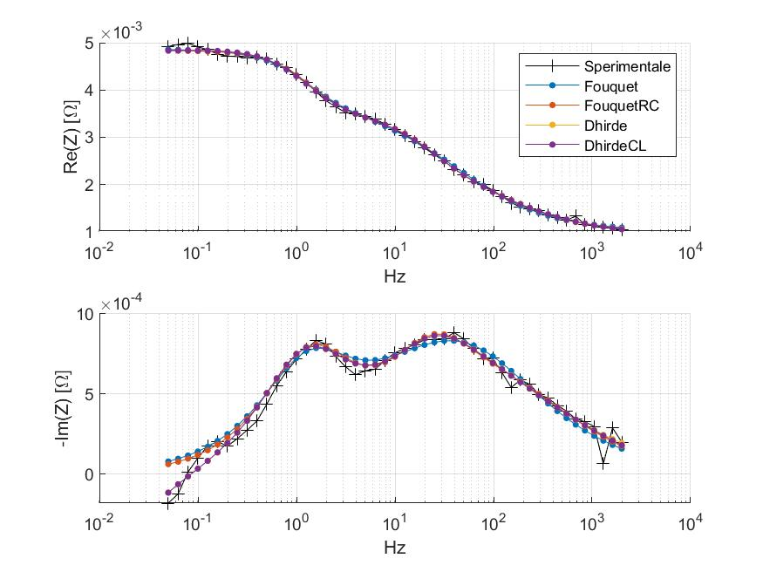

**170209_1512_dt46_fs-px_eis-25a_c00**

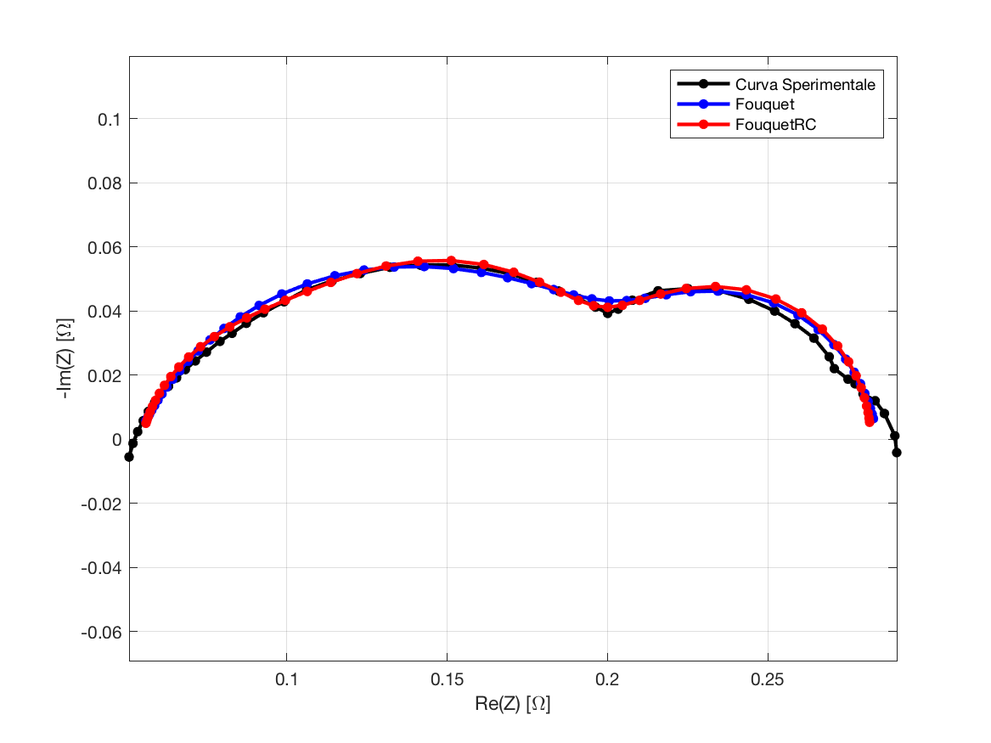

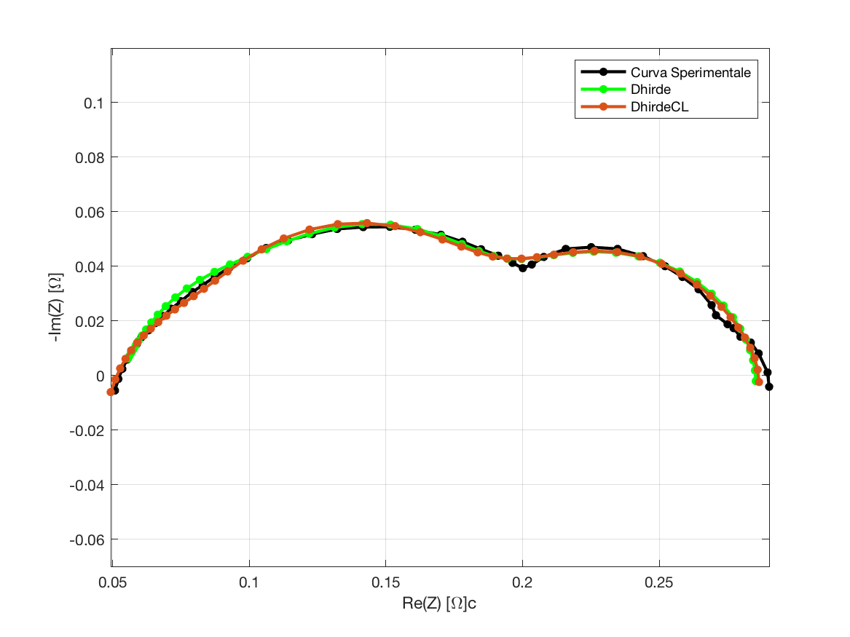

**Fouquet**

Fobj = 0.04216;

|  |  |  |  |  |  |
| --- | --- | --- | --- | --- | --- |
| Romega | Rct | Q | Phi | Rd | Taud |
| 0.0533 | 0.1537 | 0.1416 | 0.7407 | 0.0775 | 0.4419 |

**Fouquet + RC**

Fobj = 0.03617;

|  |  |  |  |  |  |  |  |
| --- | --- | --- | --- | --- | --- | --- | --- |
| Romega | Rct | Q | Phi | Rd | Taud | R | C |
| 0.0548 | 0.0619 | 0.0572 | 0.8706 | 0.0985 | 0.4446 | 0.0670 | 0.1489 |

**Dhirde**

Fobj = 0.03764;

|  |  |  |  |  |  |  |  |  |  |
| --- | --- | --- | --- | --- | --- | --- | --- | --- | --- |
| Romega | Rct1 | Rct2 | Q1 | Q2 | Phi1 | Phi2 | Rd | Taud | L |
| 0.0512 | 0.1039 | 0.0391 | 2.1921 | 0.0654 | 0.8437 | 0.9455 | 0.0951 | 0.0224 | 2.6921 |

**DhirdeCL**

Fobj = **0.02648**;

|  |  |  |  |  |  |  |  |  |  |
| --- | --- | --- | --- | --- | --- | --- | --- | --- | --- |
| Romega | Rct1 | Rct2 | Q | Phi | Rd | Taud | Lhf | Llf | C |
| 0.0271 | 0.1599 | 0.0474 | 1.8741 | 0.3333 | 0.0809 | 0.0170 | 0.0000 | 1.1890 | 3.5729 |

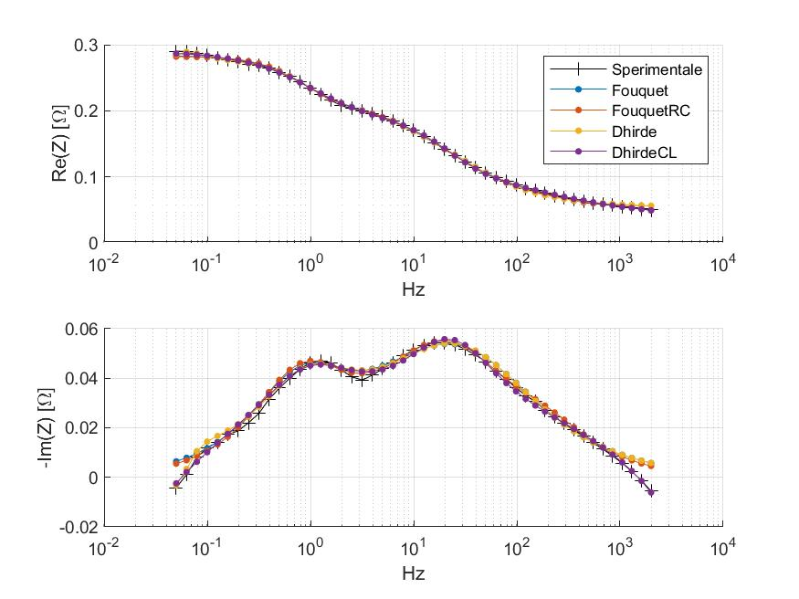

**170209_1545_dt46_fs-px_eis-40a_c00**

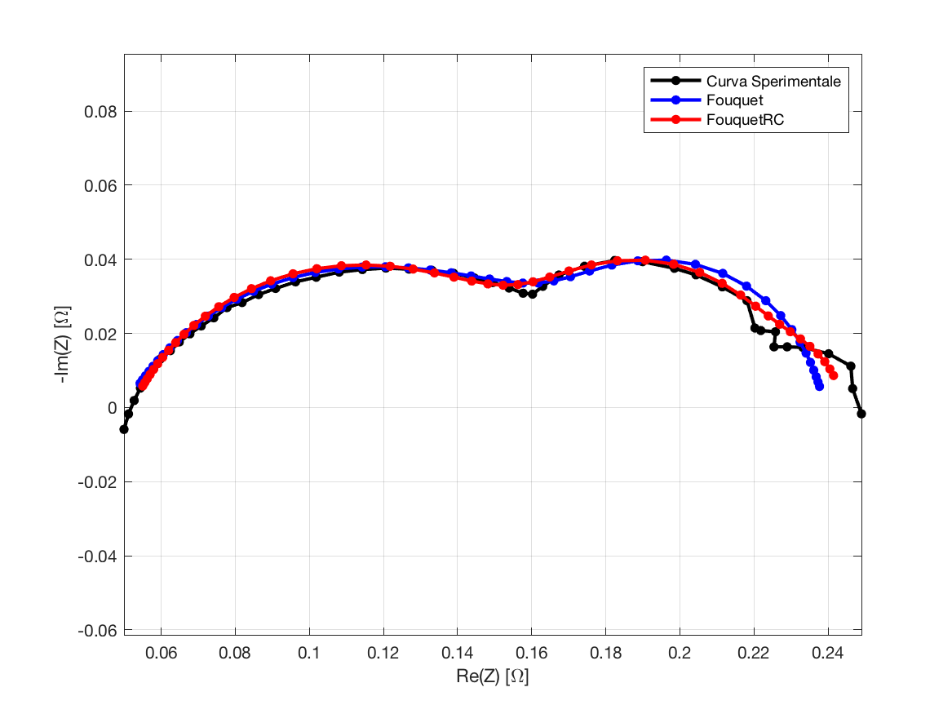

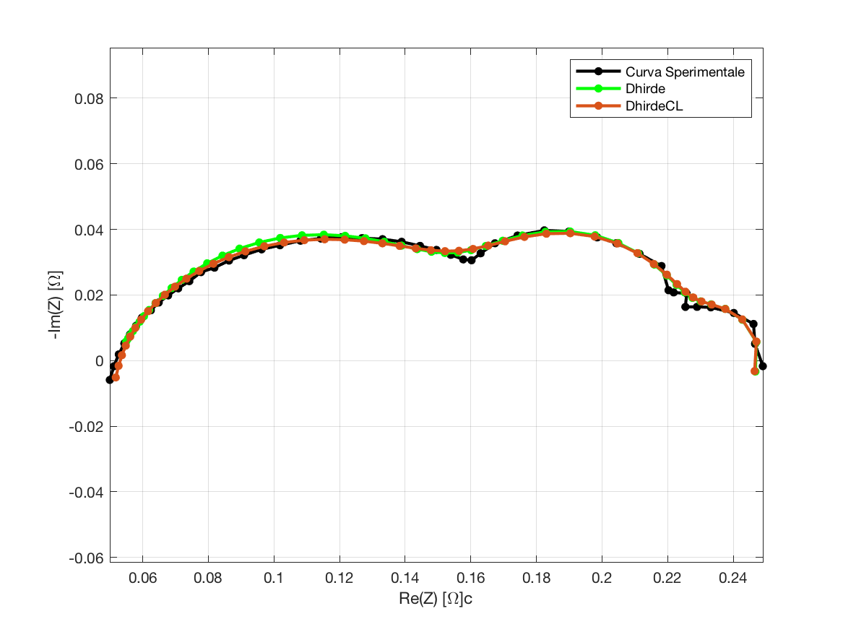

**Fouquet**

Fobj = 0.06718;

|  |  |  |  |  |  |
| --- | --- | --- | --- | --- | --- |
| Romega | Rct | Q | Phi | Rd | Taud |
| 0.0503 | 0.1177 | 0.1957 | 0.6860 | 0.0714 | 0.3983 |

**Fouquet + RC**

Fobj = 0.06260;

|  |  |  |  |  |  |  |  |
| --- | --- | --- | --- | --- | --- | --- | --- |
| Romega | Rct | Q | Phi | Rd | Taud | R | C |
| 0.0520 | 0.1138 | 0.1635 | 0.7226 | 0.0214 | 2.5208 | 0.0566 | 2.3729 |

**Dhirde**

Fobj = 0.04796;

|  |  |  |  |  |  |  |  |  |  |
| --- | --- | --- | --- | --- | --- | --- | --- | --- | --- |
| Romega | Rct1 | Rct2 | Q1 | Q2 | Phi1 | Phi2 | Rd | Taud | L |
| 0.0519 | 0.1131 | 0.0571 | 0.1672 | 2.3548 | 0.7209 | 1.0000 | 0.0294 | 6.6061 | 0.0974 |

**DhirdeCL**

Fobj = **0.03483**;

|  |  |  |  |  |  |  |  |  |  |
| --- | --- | --- | --- | --- | --- | --- | --- | --- | --- |
| Romega | Rct1 | Rct2 | Q | Phi | Rd | Taud | Lhf | Llf | C |
| 0.0462 | 0.1259 | 0.0520 | 0.2269 | 0.6459 | 0.0282 | 7.1096 | 0.0000 | 0.0854 | 2.7117 |